H.U. MECHANICAL ENGINEERING

GENERAL CHEMISTRY LAB REPORT

Determination of Molecular Weight With Freezing Point Lowering

GÖKAY KART

KIM-121-6

ZÜHRA ÇINAR

Aim

Our aim in the experiment is to find the molecular weight of a solute, so we used the freezing point depression formula and a solvent.

Solution-Solvent-Solute

* In chemistry, a solution is a special type of homogeneous mixture composed of two or more substances.
* In such a mixture, a solute is a substance dissolved in another substance, known as a solvent.
* Solvent is the larger fraction of mixture.

Characteristics

* The particles of solute in a solution cannot be seen by the naked eye.
* A solution does not allow beams of light to scatter.
* A solution is stable.
* The solute from a solution cannot be separated by filtration (or mechanically).
* It is composed of only one phase.

Concentration

Concentration is the abundance of a constituent divided by the total volume of a mixture. Several types of mathematical description can be distinguished: mass concentration, molar concentration, number concentration, and volume concentration.

Molarity(M)

Molarity is a measure of the concentration of a chemical species in terms of the amount of substance per unit volume of solution. The most commonly used unit for molarity is the number of moles per liter, having the unit symbol mol/L or mol⋅dm−3 in SI unit.

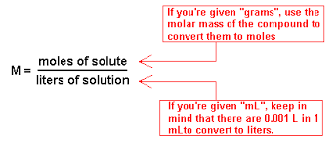

Molality(m)

Molality is a measure of number of moles of solute present in 1 kg of solvent. This contrasts with the definition of molarity which is based on a specified volume of solution. Its unit is mol/kg.

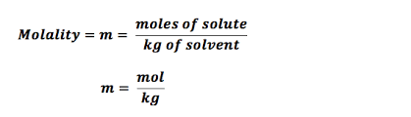

Colligative Properties

* Colligative properties are those properties of solutions that depend on the ratio of the number of solute particles to the number of solvent molecules in a solution, and not on the nature of the chemical species present.
* The number ratio can be related to the various units for concentration of a solution, for example, molarity, molality, etc.
* Only properties which result from the dissolution of non-volatile solute in a volatile liquid solvent are considered.

Colligative properties include:

* VAPOR PRESSURE LOWERING
* FREEZING-POINT DEPRESSION
* BOILING POINT ELEVATION
* OSMOTIC PRESSURE

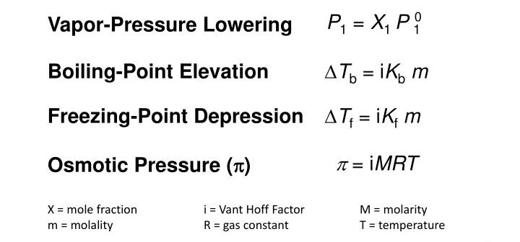

What is the freezing point?

Freezing point is the temperature at which solid and liquid forms of any substance exist together.

Freezing point depression

* Solid-liquid solutions start to freeze at a lower temperature than pure solvents.
* When pure water freezes, it stacks more easily than the solvent molecules in the solution.
* Since non-volatile solute molecules prevent the solvent from freezing, it must be further cooled to freeze.
* In addition, during the freezing of the solution, the temperature constantly decreases until it becomes a saturated solution.
* Solutions freeze the solvent at a lower temperature than in its pure form.
* The solution has no specific freezing point.
* When an unsaturated solution begins to freeze, the temperature continues to change.
* The freezing temperature of the solution that reaches saturation is constant.
* The higher the concentration of the solution, the smaller the freezing point.
* The decrease in freezing point does not depend on the type of solute.

For example;

Why don't seas freeze when lakes and rivers freeze in winter?

Since the salt ratio is high in the seas, freezing is not observed because the dissolved matter is also high.

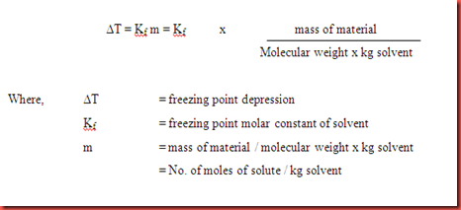

Colligative Properties for Strong Electrolyte Solution

When determining the colligative properties, the compounds (electrolyte) that are separated into their ions should be treated by considering the number of ions.

ΔTf = Tf (çözüm) −Ti (çözüm) = im x Kf

i : The van't Hoff factor

For example, while the "i" of 1 mol of C4H6 is 1, the "i" of 1 mol of CaCl2 is 3.

Data of the experiment;

Kf for water = 1.86 °C/m

Volume of water = 5 ml

Density of water = 1 g/ml

Volume of ethanol = 0.5 ml

Density of ethanol = 0.789 g /cm3

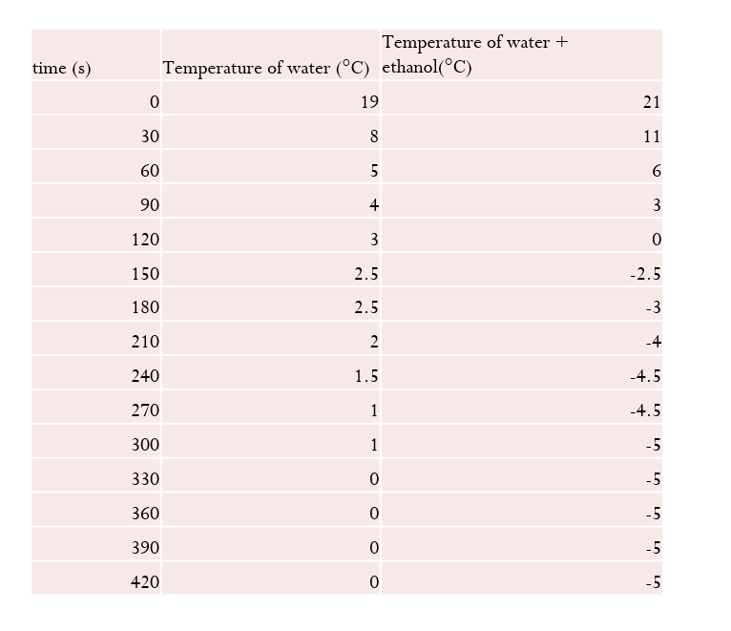

Calculations of the experiment;

* Find ΔTf from graph
* Calculate ΔTf=Kf×m
* Calculate percent error
* Calculate the molecular weight of ethanol

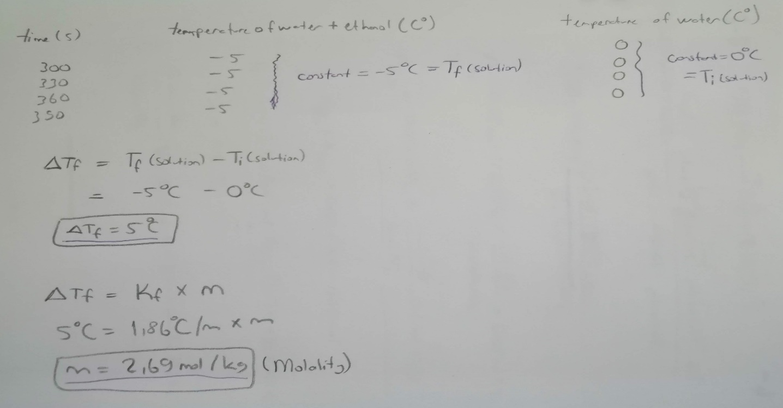

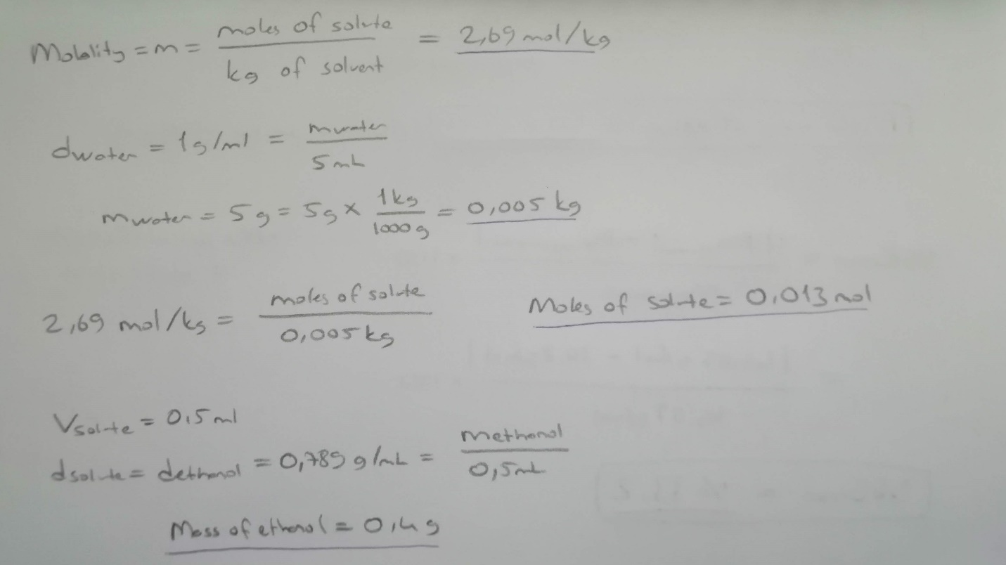

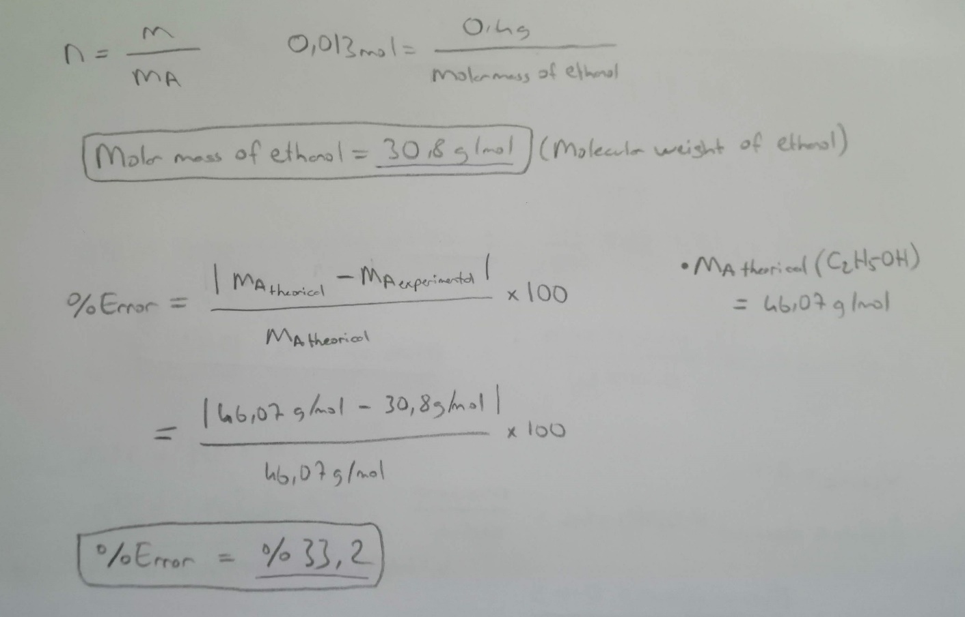

Results of the experiment;

• ΔTf >>> 5 °C

• Molality >>> 2,69 mol\kg

• The molecular weight of ethanol >>> 30.8 g\mol

• Percent error >>> %33.2

Discussion part of the experiment;

The aim of the experiment is to find the molecular weight of ethanol by adding ethanol (C2H5OH) to water and using its colligative properties.

In the experiment, we first prepared an ice bath.

What is an ice bath?

It is called creating a homogeneous solution by adding crushed ice and 5 ml of NACI into a container. The melting point of ice is related to its descent.

What does an ice bath do?

We will use the solution (H20 + C2H5OH) that we will put in a container to reduce its temperature in a controlled manner. The temperature will decrease to approximately -10 °C with an ice bath (valid for a while).

What is the purpose with an ice bath?

It is to be able to freeze water and solution.

In the experiment we created temperature time graphene of pure water (with ice bath). Then, we got the temperature and time graph values of the solution formed by adding 0.5 ml of ethanol to 5 ml of water. We finally calculated the molecular weight using these data using colligative properties (freezing point depression).

What is the Percent Error (%)?

An error was made in finding the molecular weight of 33.2% by percent error calculation.

The first factor that causes this error may be the hydrogen bonding of water with -OH. The higher the number of carbon and -OH groups, the higher the boiling point. This change may cause a change in "delta T".

The second factor may be that the temperature and time graph does not collect more detailed data. For example, the process may not have been completed between the 5th and 7th minutes.

The third factor ethanol may not be pure.

The last factor may have lost the effect of the ice bath over time and caused an error in the data.

Questions & Answers:

* A cooling curve is a plot of temperature (y-axis) vs. time (x-axis)

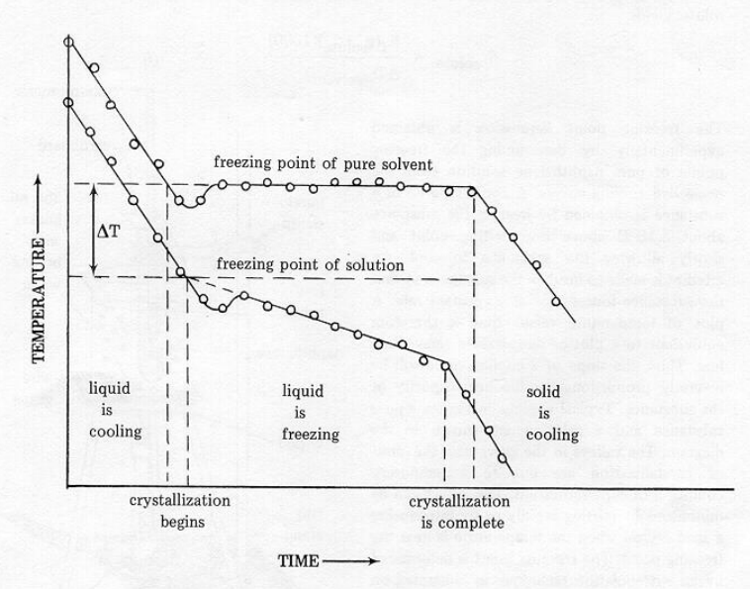

1- What's the difference reason as delta T?

Non-volatile soluble molecules prevent the solvent from freezing. The solvent needs to be further cooled to freeze. It falls on the freezing point.

2- Why is the temperature not constant for the solution during the process change?

During the freezing of the solution, the temperature constantly decreases until the solution is saturated. The freezing temperature of the solution that reaches saturation is constant.

Referenced sources:

Websites:

<https://tr.wikipedia.org/>

<https://tr.khanacademy.org/science/physics/thermodynamics/>

<https://www.canlidershane.net/>

Books:

General Chemistry Principles and Modern Applications (10th Edition, Chapter 4).